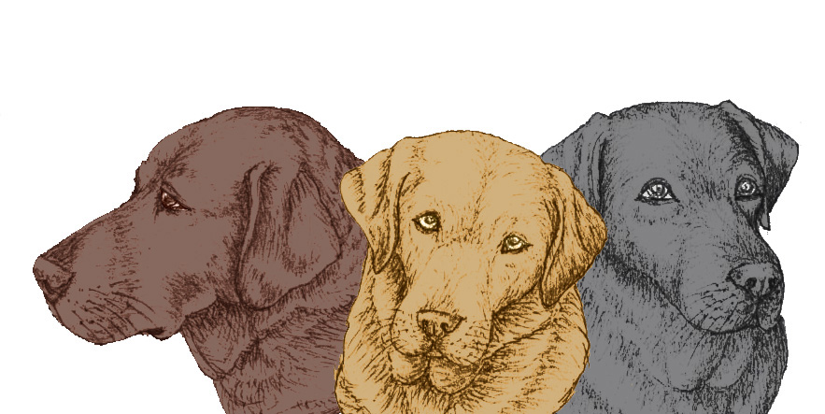LABRADOR WELFARE
90 Leader Road, Sheffield S6 4GH
E: enquiries@labradorwelfare.org
Registered Charity Number 1012192

SPONSOR DOG SCHEME MEMBERSHIP FORM
We sometimes get dogs handed over for adoption that have medical problems which require ongoing expensive medication, or they may need an operation in the future. These dogs are too young to join our foster scheme but are difficult to rehome because the new owner will not be able to insure the dog for the existing condition. We would like to be able to offer some support towards the cost of these specific conditions. There are also dogs with behavioural problems where professional help is required. If we are able to offer some financial help these dogs will stand a better chance of finding a new home. There are also dogs that for various reasons are in kennels for long spells. Your donation would help to support their kennelling bills and to buy them toys and treats.

To join the Sponsor Dog Scheme, you’ll need to make regular fixed donation by setting up a standing order with your bank and quoting the reference ‘SPONSOR’ on your standing order mandate. We leave the amount up to you but we suggest a minimum of £5 per month. For some this support will only be for a short period but for others it can be a life-time commitment. By joining the Sponsor Dog Scheme, you will make a real difference to the lives of these dogs and their owners.

I/we would like to support Labrador Welfare Sponsor Dogs:
Title ________________ Forename(s) ________________________________________________

Surname ________________________________________________________________________

Address _________________________________________________________________________

_____________________________________________ Post Code ___________________

E-mail address _______________________________________Telephone no: _________________

Signature ____________________________________________Date ________________________

GIFT AID DECLARATION
Please complete the declaration below if you’d like to add Gift Aid to your Sponsor Dog Scheme membership and make it go even further.

I confirm that I have paid or will pay an amount of Income Tax and /or Capital Gains Tax for each tax year (6 April to 5 April) that is at least equal to the amount of tax that all the charities or Community Amateur Sports Clubs that I donate to will reclaim on my gifts for the current tax year. I understand that other taxes such as VAT and Council Taxes do not qualify. I understand the charity will reclaim 25p of tax on every £1 that I have given.

Title ________________ Forename(s) ________________________________________________

Surname ________________________________________________________________________

Address _________________________________________________________________________

_____________________________________________ Post Code ___________________

E-mail address _______________________________________Telephone no: _________________

Signature ____________________________________________Date ____________________

Please notify Labrador Welfare if you: want to cancel this declaration/change your name or address/no longer pay sufficient tax on your income and/or capital gains

Please return the completed form to: Labrador Welfare, 90 Leader Road, Sheffield S6 4GH

GENERAL MONTHLY STANDING ORDER AUTHORITY

Please pay NATIONAL WESTMINSTER BANK PLC, BROOMHILL BRANCH, SHEFFIELD
Sort Code Number 54-41-34

for the Credit of LABRADOR WELFARE, Account Number 50008528 (Reference: SPONSOR)

the sum of £ (amount in figures) pounds (amount in words)

commencing the twenty-fifth day of ..................................................................... (month) 20..... and thereafter monthly on the twenty-fifth day of each month until you receive further notice from me/us in writing and debit my/our account accordingly.

Account Number | Name of Bank:
Address of Bank
Bank Sorting Code

Your Name (in full)

Your Address

Post Code

Signature(s)
Date

PLEASE RETURN THIS FORM TO YOUR BANK

