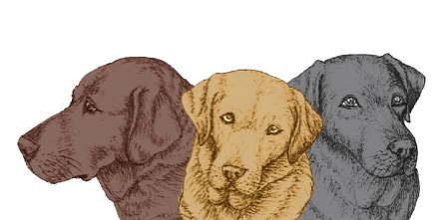**GIFT AID FORM**

I confirm that I have paid or will pay an amount of Income Tax and/or Capital Gains Tax for each tax year (6 April to 5 April) that is at least equal to the amount of tax that all the charities or Community Amateur Sports Clubs that I donate to will reclaim on my gifts for the current tax year. I understand that other taxes such as VAT and Council Taxes do not qualify. I understand the charity will reclaim 25p of tax on every £1 that I have given.

Title _________ Forename(s) _____________________________________

Surname ___________________________________________________________________________

Address ____________________________________________________________________________

____________________________________________________ Post Code ______________

E-mail address: _________________________________________Telephone No: _________________

Signature ___________________________________________________Date ____________________

**Please notify Labrador Welfare if you:** want to cancel this declaration /change your name or address/no longer pay sufficient tax on your income and /or capital gains

**Please return the completed form to:**

**Labrador Welfare, 90 Leader Road, Sheffield, S Yorks S6 4GH**