LABRADOR WELFARE

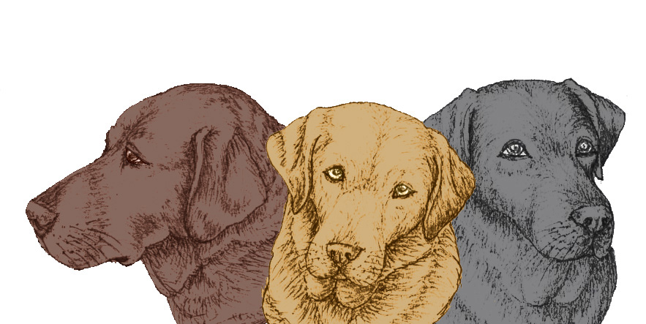

90 Leader Road, Sheffield S6 4GH **E**: [enquiries@labradorwelfare.org](mailto:enquiries@labradorwelfare.org)

Registered Charity Number 1012192

|  |
| --- |
| **LABRADOR WELFARE MEMBERSHIP & GIFT AID FORM** |
| ***I/we would like to support the work of the charity by becoming a member of Labrador Welfare***  Title ________________ Forename(s) ________________________________________________  Surname ________________________________________________________________________  Address _________________________________________________________________________  _____________________________________________ Post Code ___________________  E-mail address _______________________________________Telephone no: _________________ |
| ***I/we would like to become a member/members of Labrador Welfare as indicated below and have completed and returned the attached standing order mandate* (quoting Reference: MEMBER) *to my/our bank* *to activate membership which I/we understand will be due for renewal on 31 January each year.***   |  |  |  |  |  |  |  | | --- | --- | --- | --- | --- | --- | --- | | Annual Single Membership | £10.00 |  |  | Annual concessionary membership (per person) | £5.00 |  |  |  |  |  |  |  |  |  | | --- | --- | --- | --- | --- | --- | --- | | Annual Joint/Family membership | £15 |  |  | Life membership (per person) | £150 |  | |
| If you would like to receive our Newsletter and updates on the work we do we will need your consent and preferences about how we do this. Please indicate below the method you would prefer us to use. You can change the method by which we send you updates at any time by emailing us at [enquiries@labradorwelfare.org](mailto:enquiries@labradorwelfare.org)   |  |  |  |  |  |  |  |  | | --- | --- | --- | --- | --- | --- | --- | --- | | **E-mail** | Yes |  | No | **Post** | Yes |  | No | |
| Signature ____________________________________________Date ________________________ |

|  |
| --- |
| **GIFT AID DECLARATION** |
| Please complete the declaration below if you’d like to add Gift Aid to your Labrador Welfare membership and make it go even further.  I confirm that I have paid or will pay an amount of Income Tax and /or Capital Gains Tax for each tax year (6 April to 5 April) that is at least equal to the amount of tax that all the charities or Community Amateur Sports Clubs that I donate to will reclaim on my gifts for the current tax year. I understand that other taxes such as VAT and Council Taxes do not qualify. I understand the charity will reclaim 25p of tax on every £1 that I have given.  Title ________________ Forename(s) ________________________________________________  Surname ________________________________________________________________________  Address _________________________________________________________________________  _____________________________________________ Post Code ___________________  E-mail address _______________________________________Telephone no: _________________  Signature ____________________________________________Date ________________________  **Please notify Labrador Welfare if you:** want to cancel this declaration/change your name or address/no longer pay sufficient tax on your income and/or capital gains |

**Please return the completed form to: Labrador Welfare, 90 Leader Road, Sheffield S6 4GH**



**MEMBERSHIP STANDING ORDER AUTHORITY**

Please pay NATIONAL WESTMINSTER BANK PLC, BROOMHILL BRANCH, SHEFFIELD

Sort Code Number **54-41-34**

for the Credit of **LABRADOR WELFARE** Account Number **01003976 (Reference: MEMBER)**

the sum of £ _______ (amount in figures) ____________________________ (amount in words)

commencing on ..................................................................... 20......... and thereafter annually on the 31st January until you receive further notice from me/us in writing and debit my/our account accordingly.

|  |  |
| --- | --- |
| **Account Number** | **Name of Bank:** |
| **Address of Bank** | |
| **Bank Sorting Code** | |

|  |
| --- |
| **Your Name (in full)** |
| **Your Address**    **Post Code** |

|  |
| --- |
| **Signature(s)** |
| **Date** |

# **PLEASE RETURN THIS FORM TO YOUR BANK**